Nepal College of Information Technology
Assessment
Spring 2010
Program : BE ELX Time : 3 hrs
Semester : Spring (IV) FM : 100
Subject : Numerical Method PM : 50
- Candidates are requested to give their answer as far as practicable in their own words.
- The figure in the margin indicates the full marks
- Attempt ALL question
1. a) Solve 3x+Sinx-e^{x}=0 by secant method, correct to three decimal place. 7
b) 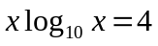by N-R method, correct to four decimal place. 8
2. a) Fit the interpolating polynomial to the following data.

x | 1.20 | 1.25 | 1.30 | 1.35
f(x) | 0.1823 | 0.2231 | 0.2624 | 0.3001

Find f(1.22). 7
b) Fit a second degree polynomial to the following data by least square approximation method.

x | 10 | 12 | 15 | 23 | 20
y | 14 | 17 | 23 | 25 | 21
8
OR
Fit a curve of the form y=ae^{bx} to the following data in least square sense:

x | 0 | 2 | 4
y | 5.012 | 10 | 31.62

3. a) Evaluate 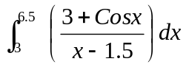 by 8
i) Trapezoid rule
ii) Simpson's Rule
iii) Simpson's Rule
b) Evaluate 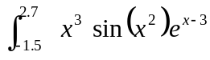 by Gaussian three point formula. 7
4. a) Solve the following set of equation
x + y+ z = 3
2x-y+3z=16
3x+y-z =-3
by Crout's method. 8
OR
Solve

10x | -2y | -z | -w | = | 3
-2x | +10y | -z | -w | = | 15
-x | -y | +10z | -2w | = | 27
-x | -y | -2z | +10w | = | -9

by Gauss-seidal method.
b) Find the dominant eigen value and corresponding eigen vector of the matrix.
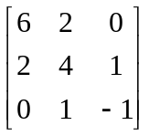 7
5. a) Solve
=Sinx+y, y(0)=2 by Huren's method for y(1) taking h=0.5 7
b) Solve y"+2y'=x²+y, y(0)=1, y'(0)=-1 for y(0.2) by method of RK 4th order. 8
6. a) Solve the equation
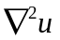=-10(x²+y²+10) over the square mesh with sides x = 0, y = 0, x = 3, y = 3 with u = 0 on the boundary and mess length h=1. 10
b) Write an algorithm for Secant method. 5
7. Write short notes on (Any two) 2*5=10
a) Error's in numerical computing.
b) Ill condition system in solving linear equations.
c) Taylor's series method for solving differential equations.

